**The Bisection Method**

**Theory**

This method is based on the theorem stating that if a function f(a) is continuous between a and b, and f(a) and f(b) are of opposite signs then there exists at least one root between a and b and its approximate value is x = (a+b)/2 . If f(x)=0 then it is concluded that x=0 is the root of the equation f(x)=0. Otherwise the root lies between either x and b or x and a depending on whether f(x) is positive or negative. This process continues until the desired value of root x is acquired. Thus this is the procedure of the bisection method.

**Code**

#include<iostream>

#include<stdio.h>

#include<cmath>

using namespace std;

#define Eps 0.00001

double f(double x)

{

return (x*x*x)-2*x-5;

}

int main()

{

double a,b,x,xn;

int i=0;

cout<<"Enter the Value of a: ";

cin>>a;

cout<<"Enter the value of b: ";

cin>>b;

x=(a+b)/2;

if(f(a)*f(b)>0)

cout<<"WRONG INPUT. \nPlease Try Again !!!"<<endl;

else

{

cout<<"n"<<" "<<"a"<<" "<<"b"<<" "<<"x"<<" "<<"f(x)"<<" "<<"Error Rate"<<endl;

do

{

cout<<"----------------------------------------------------------------------------------"<<endl;

printf("%d %0.5lf %0.5lf %0.5lf %0.5lf %0.5lf\n",i,a,b,x,f(x),fabs(x-xn));

xn=x;

if(f(a)*f(x)<0)

b=x;

else if(f(a)*f(x)>0)

a=x;

else if(f(a)*f(b)==0)

{

x=0;

break;

}

x=(a+b)/2;

i++;

}while(fabs(x-xn)>=Eps);

cout<<"\nThe Value of x is: "<<x<<endl;

cout<<"Error rate: "<<error(x)<<" %"<<endl;

}

return 0;

}

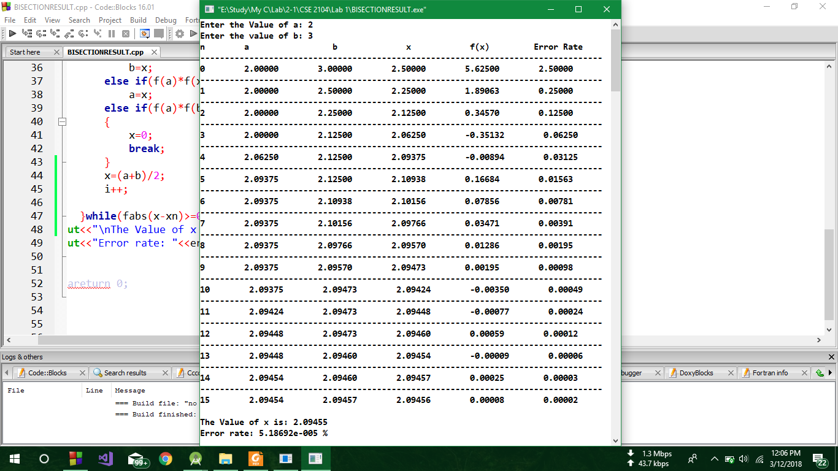**Output**

**Discussion**

In the above code, firstly a function f() was declared as it hold the main equation f(x) = x^3-2*x-5 = 0. Then in the main function a do while loop was executing until the difference of the two consecutive roots of the equation became less than 0.00001. Firstly the value of a and b were taken from the user. In the loop it was checked whether f(a) and f(x) are of opposite signs or not. If so then the value of x was assigned to b, otherwise the value of x is assigned to a. If f(x) becomes 0 then the root x=0. And then this equation x = (a+b)/2 was used. Thus this is the process of Bisection method and the result and all the values were shown as a tabular form.